To create an new environmentfor particular project we use command below in anaconda prompt

conda create -n tensorflow1 python=3.6.9

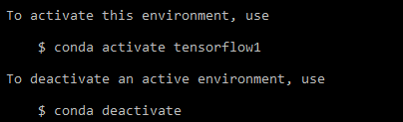

pip install jupyter = to install jupyter

Pip install tensorflow==1.14.0

Tensorflow complete guide link

<https://www.tensorflow.org/api_docs/python/tf>